ISSUES IN BRAND FUND TOOLS

* Data is not getting split-   
  Example- we have first entry 1-31st May and second 21st -22nd may then we need first entry to automatically split and start from 23rd to 31st May with same Funding
  + [27th May]: Splitting was happening only problem was that result was not getting sorted.] – Data still not getting split.
  + [28th May]: It was happening in few scenarios and fixed it. – Not Fixed yet
  + [29th May]: As per test file we had same entry date that’s why it was not getting splitting. However it is fixed in latest tool where we have applied logic based on row number.
* If approval required is Yes and Approved by is empty- it should throw an error.
* [27th May]: Initially it was not informed that’s why it was not incorporated. Seems “Approval required” will be available only in “Single SKU discounting” tab basis data provided, and it is implemented in current version.]- Still not implemented as this tool is processing the entry in which approval required is Yes but approved by is empty.
* [28th May]: I ran it again with last test file and it is working fine. Request you to share any instance so that I can review it. - Fixed
* There are some cases where we have value in SF/BF but in output it is not showing
  + [27th May] [Fixed] – Fixed
* If there is %% in SF/BF, it should throw error.
  + [27th May] [Implemented]- Still this entry is getting processed.
  + [28th May] – Fixed- Fixed
* In offer type ABSOLUTE, we are not getting any value in SF/BF.
  + [27th May] [Fixed]- Still we are not getting any value in SF/BF.If the offer type is ABSOLUTE and the tab is BF Modification, then the same value should parse into BF.
  + [28th May]: I ran it again with last test file and it is working fine. Currently it is putting whatever numbers are available in SF/BF. For example we have City value is 10,SF is 5 ,BF is 3 then it is putting same value in result tab. Request you to share any instance so that I can review it.- By default we have absolute in BF modification tab only and in BF modification SF should be 0 and BF should be equal to VALUE.

Cases where we have SF/BF in Rs, will be considered as percentage.

* + [29th May]: Implemented. On BF Modification tab we should keep value in BF column and SP will be empty and SF should be 0
* If we have two d/f in two cities which is not matching SF/BF then that should marked as an Error.
  + [27th May] [Request you to provide clarity with example]- If entry in any of the city is not matching the funding sum then it should not be processed.  
    Example- If we have 20% is all cities except Delhi in which we have 80% and then SF+BF is 20% then that entry should not be process as One city in that entry is having error.
  + [28th May] It was applied for sheet [BMSM, BXGY, Combo2, Combo3, Combo5, Foc] with error “BF/SF is invalid value” was getting generated on error tab along with result. In latest tool it will show error with city name in this scenario and data would also not available o result tab.- Fixed
* Tool is not working on Large Data
  + [27th May] [Yes it was happening due to large data size. It was taking more than an hour when we were choosing latest test file. In latest tool we have attached Access File which is being used for backend data processing. Now with this technique it can execute in less than 10 minutes with same test file.]- Fixed, now processing is really fast.
* We are not receiving any value in SF/BF from BF Modification Tab.
  + [27th May] [In previous sample files SF/BF was not there that’s why it was not implemented. Now it will pick data]- We don’t have SF/BF column in BF Modification tab as all the entries are consider as BF in that entry and still we are not getting any value in BF in BF modification.
  + [28th May] Means value available corresponding to City in BF Modification tab should be dump in BF column in result right? If yes then Value column should be blank for this tab.- Yes, the same must be done.
  + [29th May]: Now Data is getting dumped in BF column. SF & Value will be blank.
* Value is not getting passed in SF/BF wherever it is 100% in percentage Case.
  + [27th May] [Request you to provide example]- Fixed
* If there is any other entry in a particular row, then it should neglect that row and continue from next.
  + [27th May] [Request you to provide example]- If there is any random text in a particular row other then entry then it should not be processed, which is I guess is already being done.
  + [28th May] Yes, it is happening right now with error flag. As we are not able to identify that raw is not useful to us.
* We need one more offer type i.e. Flat Prices.
  + [27th May] [Added]- 👍👍
* Case where we have Offer type as Flat and we have SP and funding in Rs. then We will only consider SF/BF, and SP column value will be deleted.
  + [27th May] [Request you to provide example]

|  |  |  |  |  |  |  |  |  |  |
| --- | --- | --- | --- | --- | --- | --- | --- | --- | --- |
| **Entry Date** | **Item ID** | **Reason** | **Approval required** | **Approved By** | **Name** | **Offer Type** | **Bengaluru** | **SF** | **BF** |
| 20-May | 10040518 | Primary BF | Yes | Gautam |  | Flat price | 150 | 25% | 3% |

In this case, SP column should be empty.

[28th May] On which tabs do we need to apply it?

As I can understand If we have multiple cities column and all columns are not filled then we will be putting value corresponding to those cities where we have filled value. (Example SF 25% and BF 3% for each cities in that row)

Yes, we will put the value only on those cities in which the we have filled value.

* + [29th May]: If value is in % then offer type will be % and value column should be blank with SF & BF %.(Need to work)
* Flat price cases should not be considered as ABSOLUTE as we need SP in Flat prices but not in ABSOLUTE
  + [27th May] [Request you to provide example] – This is done as we have introduced New offer type that is Flat
* Wherever there is Flat price, we should get 100% either in SF or BF
  + [28th May] As per above excel grid we have Flat Price with SF25% and BF3% then should we go with 25% & 3% combination or 100%.- So, wherever we have flat price with % value in SF/BF, that will be considered as PERCENTAGE and Value column will be empty.
  + [29th May]: Need clarity on below different scenarios

|  |  |  |  |  |  |  |  |  |  |
| --- | --- | --- | --- | --- | --- | --- | --- | --- | --- |
| **Entry Date** | **Item ID** | **Reason** | **Approval required** | **Approved By** | **Name** | **Offer Type** | **Bengaluru** | **SF** | **BF** |
| 20-May | 10040518 | Primary BF | Yes | Gautam |  | Flat price | 352 | Rs. 527 | Rs. 20 |
| 20-May | 10040519 | Primary BF | Yes | Gautam |  | Flat price | 1519 | 100% |  |
| 20-May | 10040518 | Primary BF | Yes | Gautam |  | Flat price | 179 |  | Rs. 6 |

* + 1. Abs,sf=527, bf=20 and value =empty
  + 2.Offertype=flat, value=1519, sf=empty,bf=0
  + 3. If value is available in bf then offertype will be absolute and value=empty, bf=6 sf will empty. [need to work]
* BF column cannot be Empty.
  + [27th May] [Since we don’t have BF column on each sheet. So, request you to provide sheet name where we should apply this rule]- This must be applied in all the sheets BF can not be empty either is can have some value, or it can be 0.
  + [28th May] It was already implemented for few tabs. Now implemented for all the tabs where BF Column will be available.- It should also be applied in BF Modification also.
  + [29th May]: linked to above point
* SF Column can only be empty if we have Flat Price as Offer type or LQ fund.
  + [27th May] [Since we don’t have LQ column in most of sheet. So, need clarity on it.]- So the point is every time where the offer type is FLAT and we have 100% SF, we want SF column to be empty.
  + [28th May] Below is grid where we have Flat offer type and different value in city column. Request you to provide final result for these entries:

|  |  |  |  |  |
| --- | --- | --- | --- | --- |
| **Offer Type** | **Kolkata** | **Faridabad** | **SF** | **BF** |
| Flat price | 169 |  | 100% |  |
| Flat Price | 175 | 160 | 100% |  |

* + Expected:

|  |  |  |  |  |
| --- | --- | --- | --- | --- |
| **City** | **Type** | **Value** | **SF** | **BF** |
| Kolkata | flat | 169 | 100% |  |
| Faridabad | flat | 175 | 100% |  |
| Faridabad | flat | 160 | 100% |  |

* + Actual:

|  |  |  |  |  |
| --- | --- | --- | --- | --- |
| **City** | **Type** | **Value** | **SF** | **BF** |
| Kolkata | flat | 169 |  | 0 |
| Faridabad | flat | 175 |  | 0 |
| Faridabad | flat | 160 |  | 0 |

* + [29th May]: Above logic has been implemented.
* Offer type is getting generated as per below grid:
  + Percent 🡺 PERCENTAGE
  + Price 🡺 FLAT
  + Flat 🡺 FLAT
  + flat price 🡺 FLAT
  + flat prices 🡺 FLAT
  + absolute 🡺 ABSOLUTE
* Red colored entries should not be considered which is not being done in this case.
  + [28th May] It is possible basis certain predefined color code (every color has their numerical value). But whenever we will have slight changes on color then it tool would not be able to pick data.

I can suggest that we should add one column in Result Tab to pick color available on ItemID cell and we can filter using that column on Result tab. Please suggest.- You can pick the values for actual red color #ff0000 color RGB value is (255,0,0).

* + [29th May]: Applied
* Only those entries in which flat price is there and SF/BF is empty or

where we have SF/BF in rupees then Offer type should be ABSOLUTE and Value column should be empty.

* 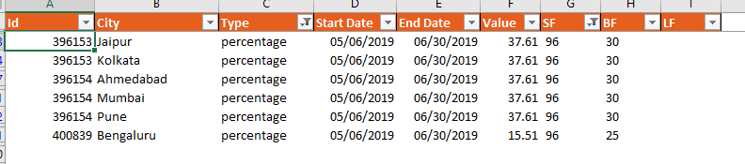
  + [28th May] Should I develop logic that if we have value >100% then it will be Absolute.- This is discussed below, in the last.
  + [29th May]:Whenever SF/BF is in Rs then offertype will be Absolute and number
* Wherever we have SF/BF in percentage then the offer type should be PERCENTAGE and Value column should be empty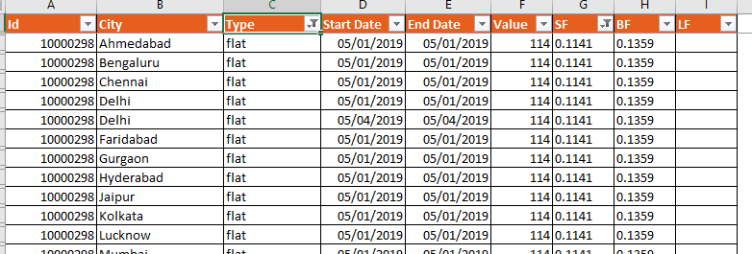
  + [28th May] Should I develop logic that if we have value <=100% then it will be Percentage. – Wherever the value is in % or <1, should be considered as percentage, this is also discussed below in the last.
  + [29th May]:We don’t need sf+bf = 100% logic. Will have to apply as percentage with sf/bf value and value will be empty
* We can only have value “VALUE” field when type is Flat.
  + [29th May]:
* In BF modification Tab, SF will remain 0 in all cases and all the value in “VALUE” field will be shifted to BF in percentage form.
  + [28th May] Request you to provide example basis below scenario

|  |  |  |  |  |  |
| --- | --- | --- | --- | --- | --- |
| **Entry Date** | **Item ID** | **Funding Type** | **Bengaluru** | **Mumbai** | **Pune** |
| 43577 | 10012513 | ABSOLUTE |  | Rs. 10 | Rs. 10 |
| 24Apr | 10008991 | PERCENTAGE | 5% |  |  |
|  |  |  |  |  |  |

City Item id funding type sf bf

Mumbai 10012513 ABSOLUTE 0 10

Pune 10012513 ABSOLUTE 0 10

Bengaluru 10008991 PERCENTAGE 0 10

* + [29th May]: Implemented. But I think third line should be 5% as funding type is percentage.
* Need clarity om how this tool is working in the below example as this is thrown in Error which is not.
  + [28th May] I don’t think below is error. However you may refer to Error log tab as there we have error description available.

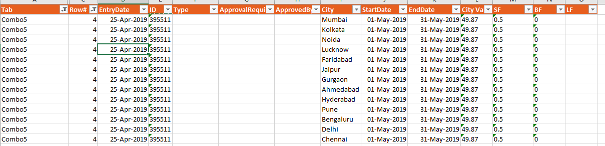

Note-

So Offer types will be defined as –

If SF/BF is 100% then

Offer type – Flat

SF = 100% then BF 0, BF=100% then SF 0

Value = Value

If SF/BF is in Rs. Then

Offer type- ABSOLUTE

If SF is empty then SF = 0, Vice versa

Value = Empty

If SF/BF is in % or <1, then

Offer type – percentage

If SF is empty then SF = 0, Vice versa

Value Field = Empty

In case of BF Modification

Offer Type – IF Rs. Then Absolute else Percentage

If SF is empty then SF = 0, Vice versa

Value Field =Empty

[29th May]: